AnsibleManager IPv4 address
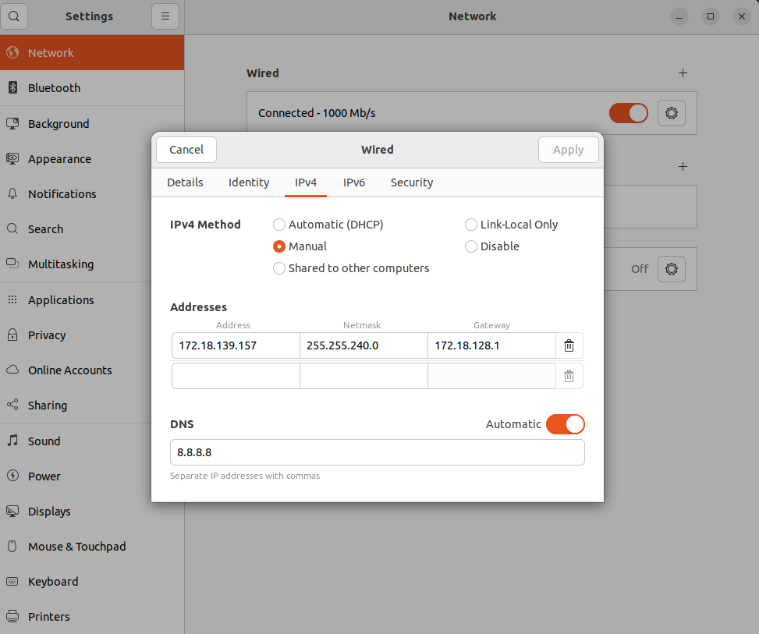
Installer-Config.yaml file
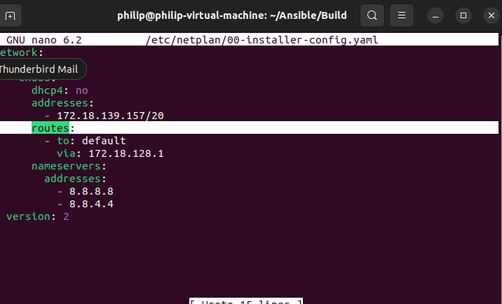
Proof of connectivity with AnsibleManager
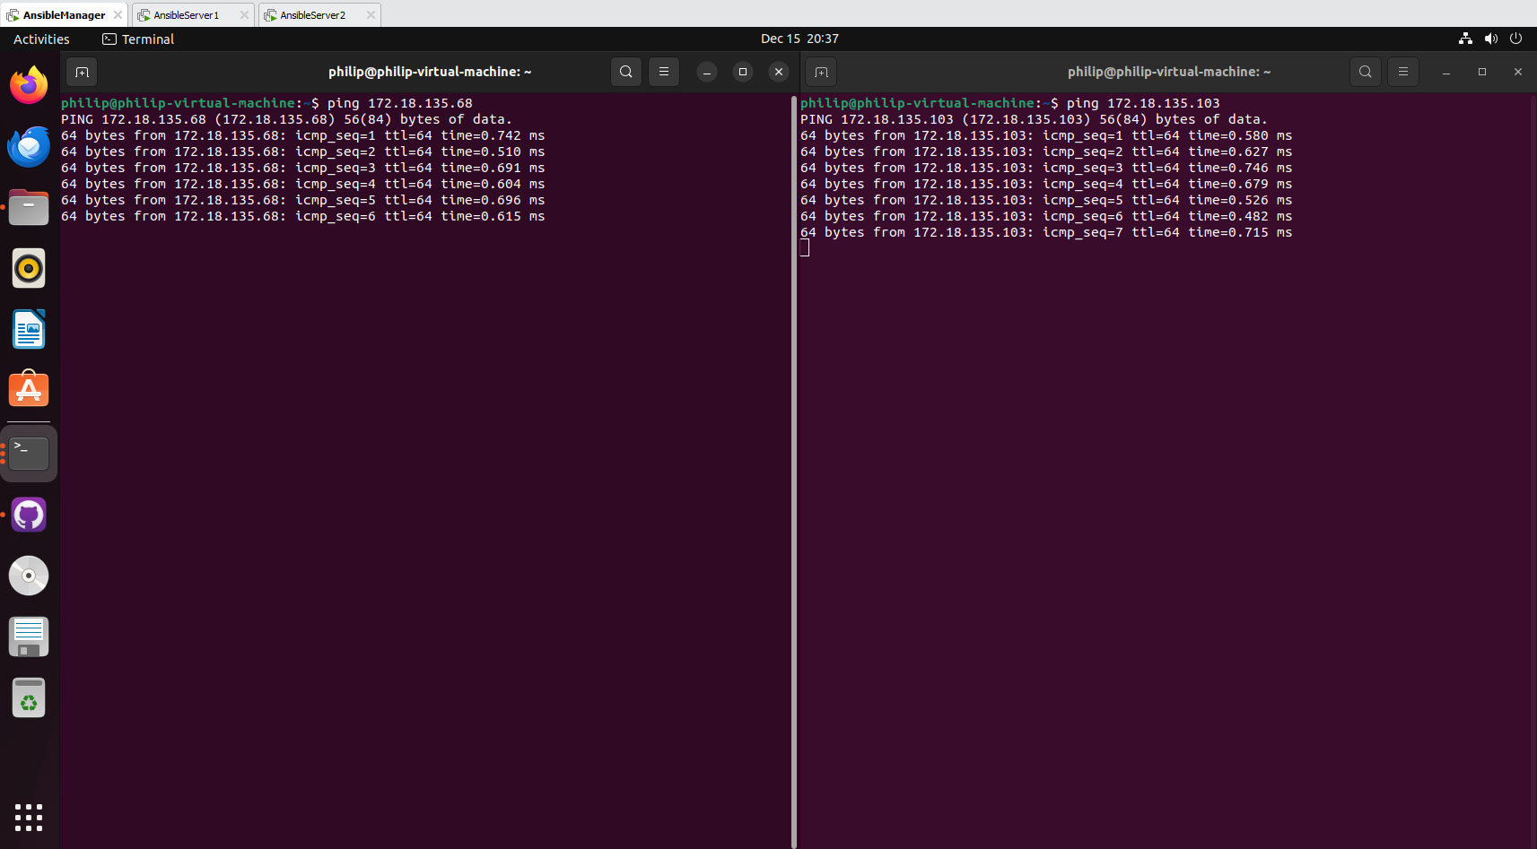

Installing openssh
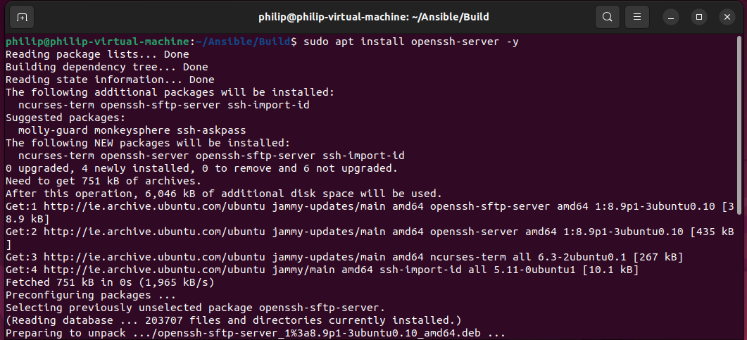
Adding key (student number is the password)
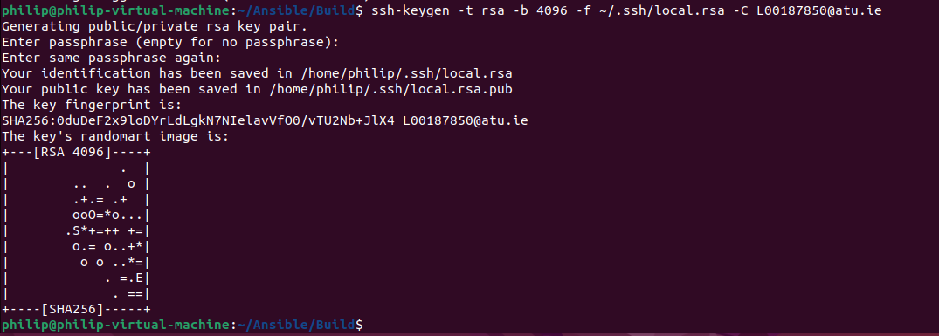
Using ssh to automatically get into ansibleserver1
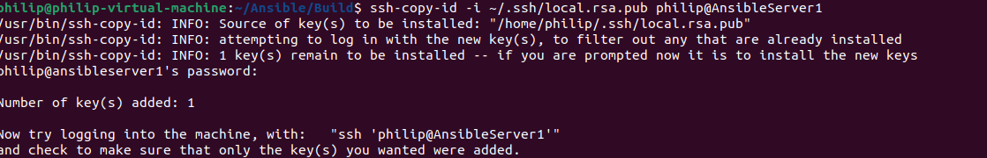
No password required after implementing on ansibleserver2
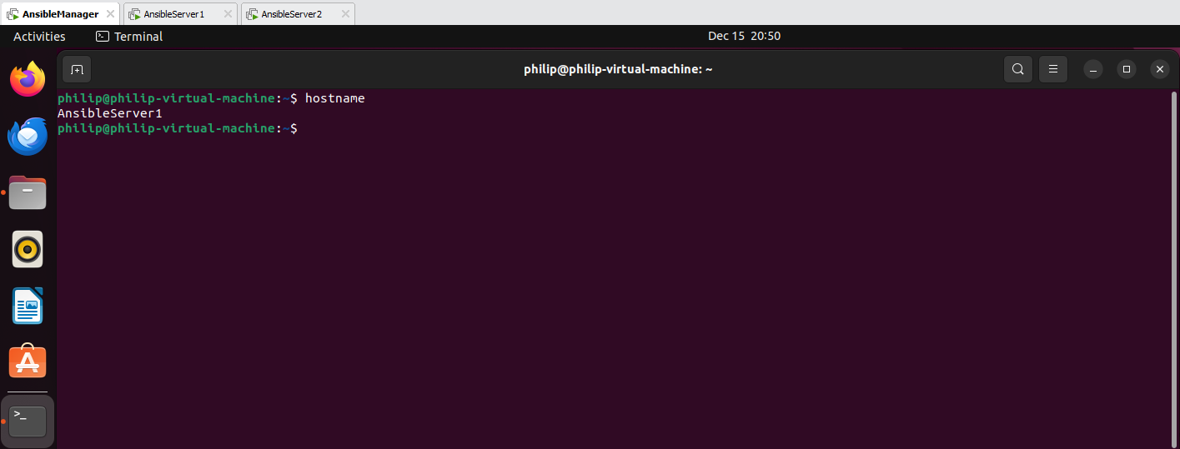
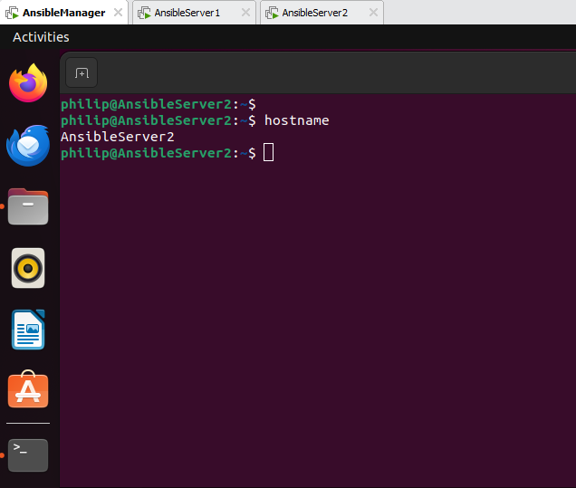

Installing Ansible
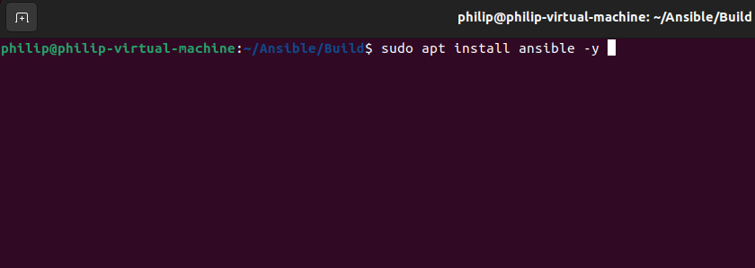

AnsibleServer1 IPv4 address
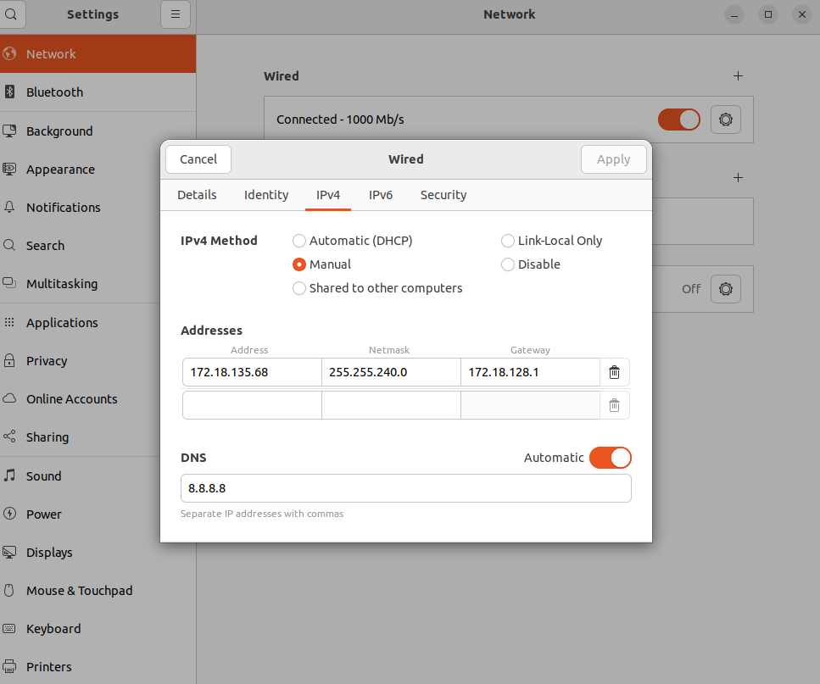

Connectivity with AnsibleManager and AnsibleServer2
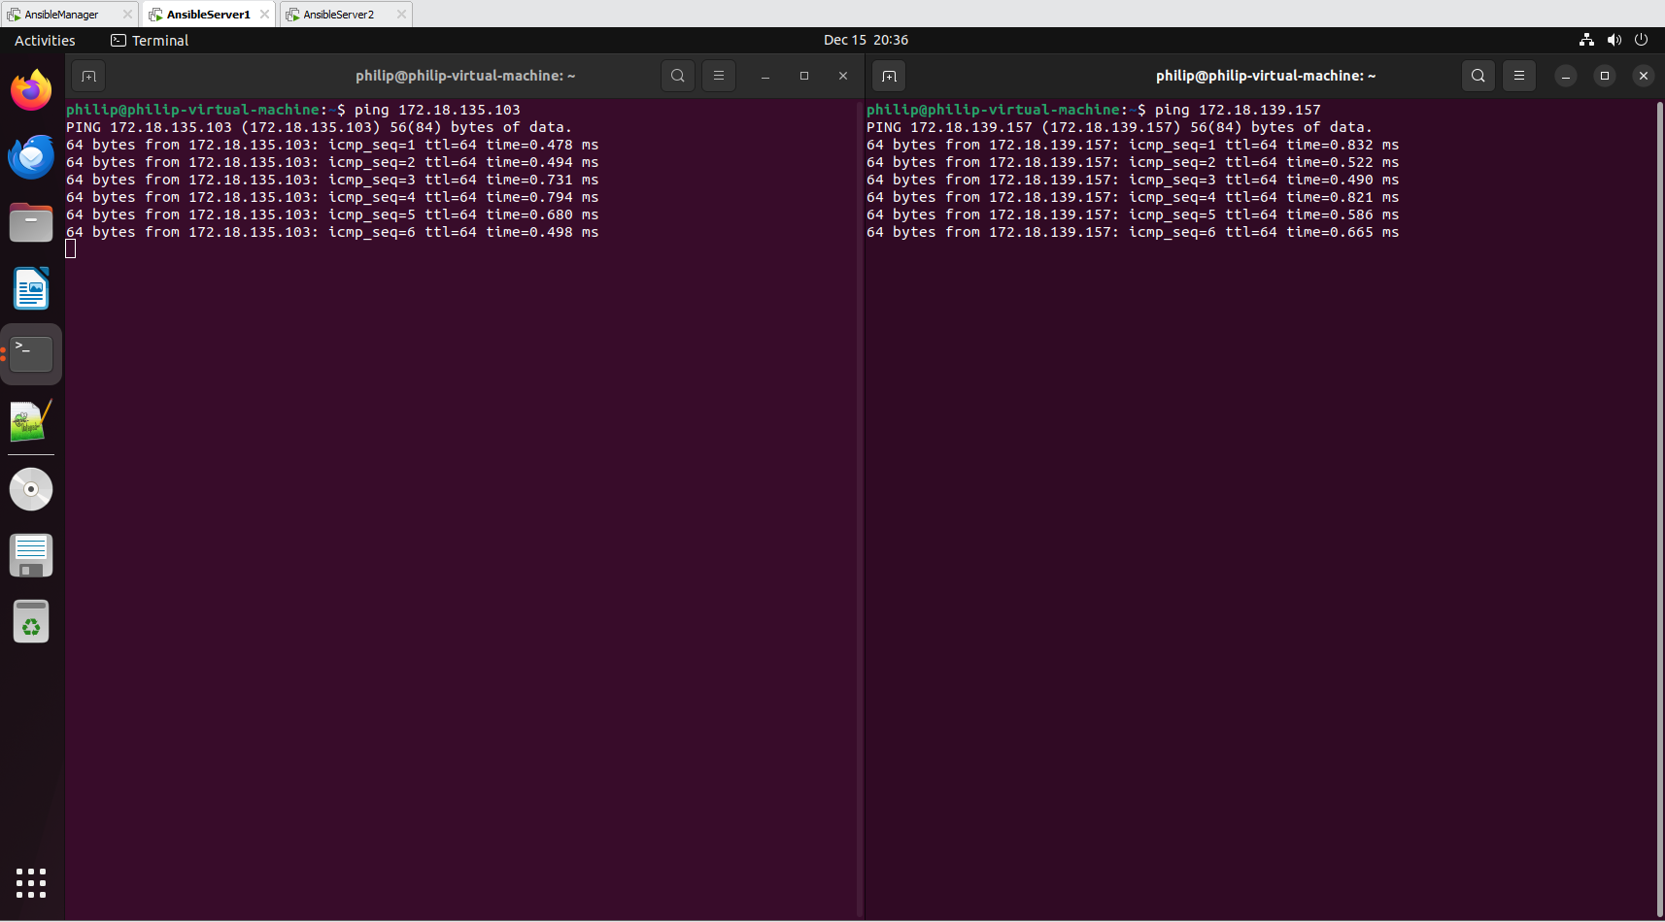

AnsibleServer2 IPv4
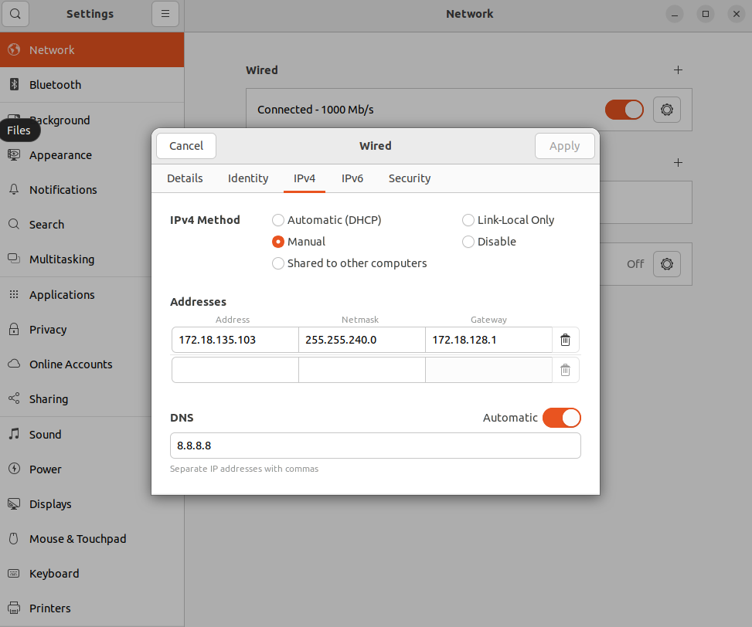

Connectivity with AnsibleManager and AnsibleServer1
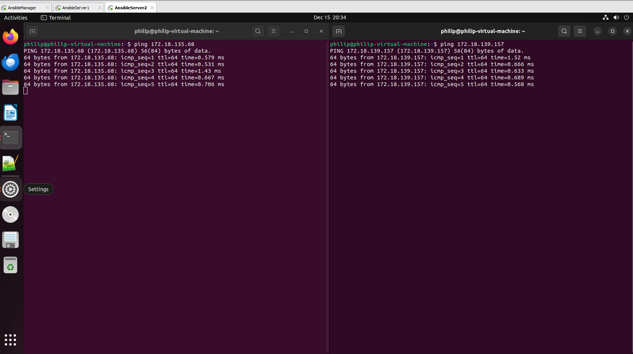

Editing etc/hosts in AnsibleManager
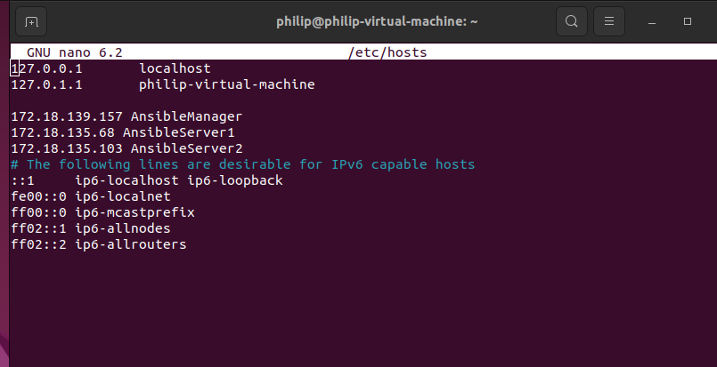

Proof of connectivity using names
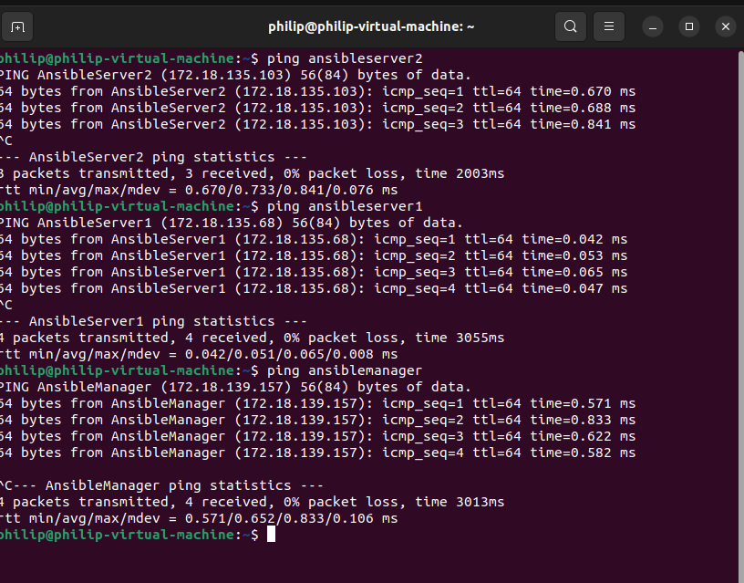

Once ansible is installed, showing the /etc/ansible/hosts being edited to include different groups and servers.
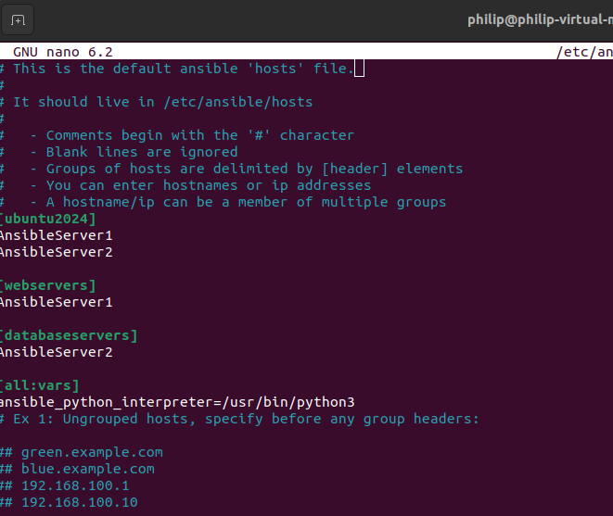
Resulting inventory from the command “ansible-inventory --list -y”
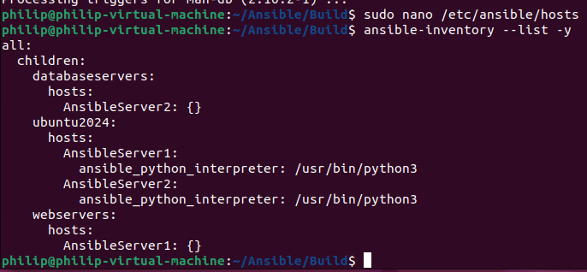

Using ansible to show ssh access to the user Philip on both devices
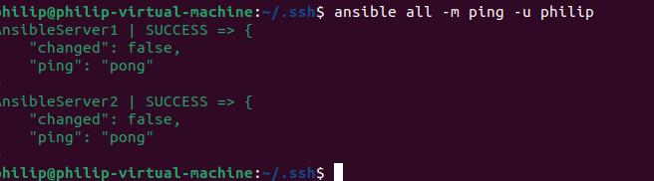
Showing that commands can affect multiple machines at once, for example disk space on every server
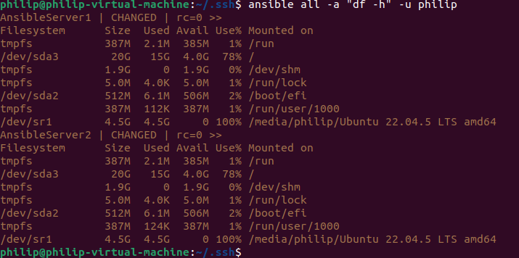

Running ansible-playbook command “ansible-playbook Updates.yml –ask-become-pass. Note that I had to change “get_md5: no” to “get_checksum: yes”
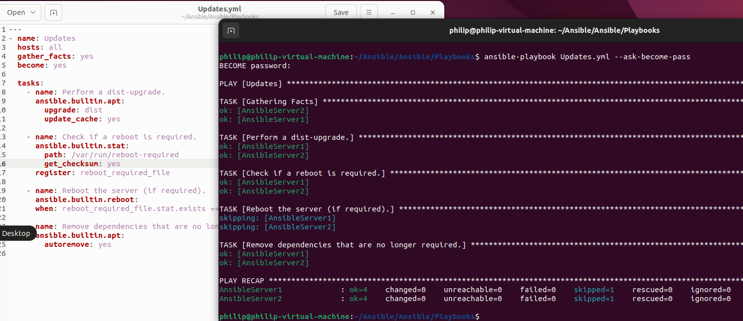

Using ansible to install Apache on all devices in the webservers group/hosts
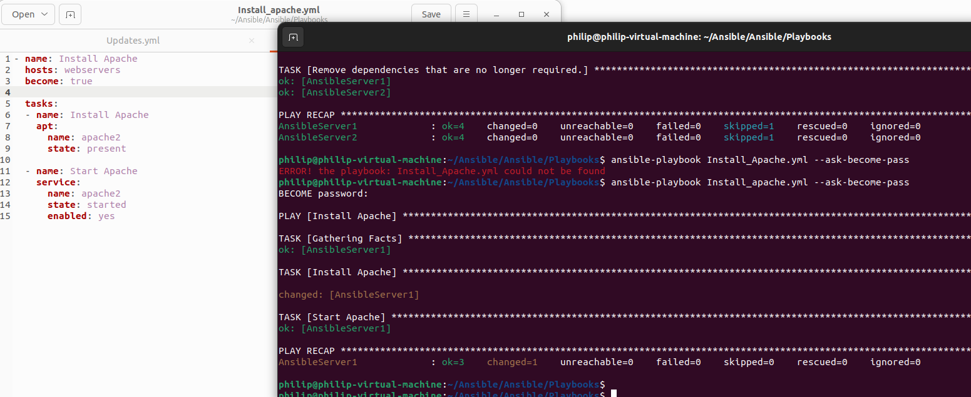
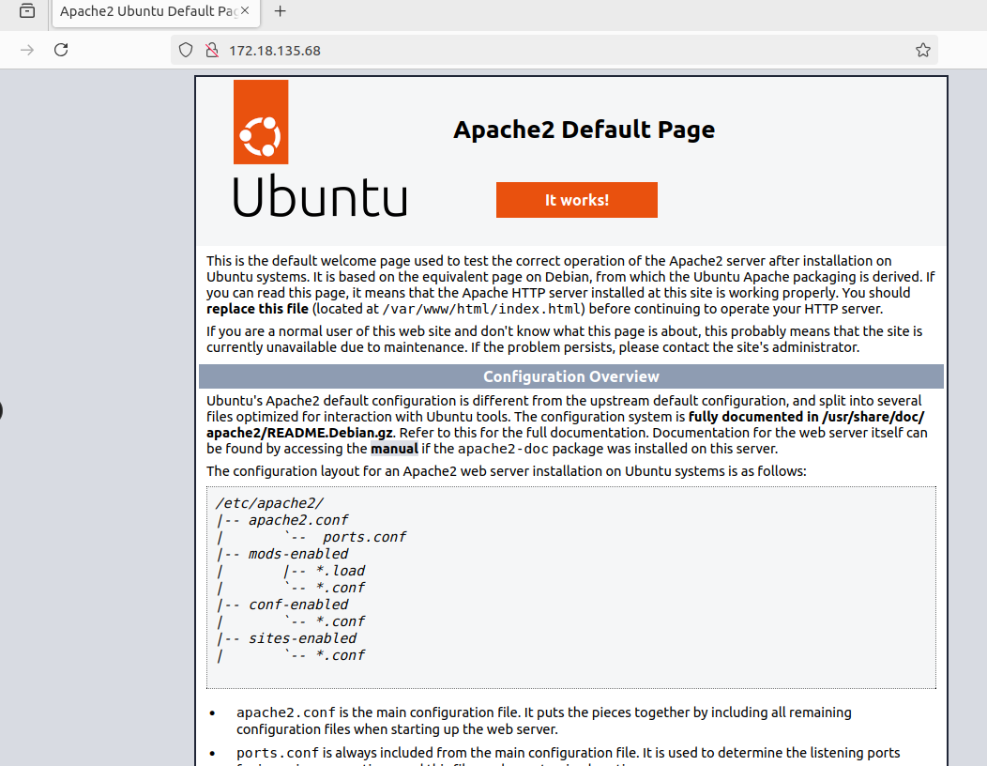

Installing MariaDB on “databaseservers” group/hosts
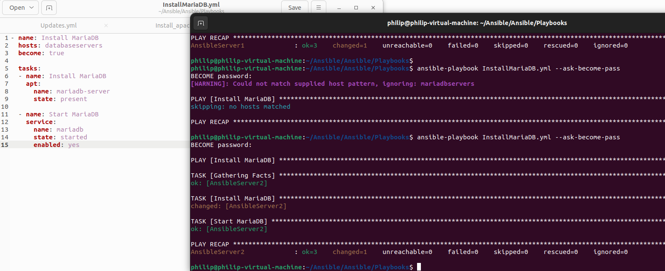

Proof that MariaDB is installed on AnsibleServer2
